Course Mathematics Specialist Year 12

Student name: ________________________ Teacher name: ________________

Date: 5 March 2021

Task type: Take home - Investigation

Time allowed for this task: 1 week

Number of questions: 6

Materials required: Calculator with CAS capability (to be provided by the student)

Standard items: Pens (blue/black preferred), pencils (including coloured), sharpener, correction fluid/tape, eraser, ruler, highlighters

Special items: Drawing instruments, templates, notes on one unfolded sheet of
A4 paper, and up to three calculators approved for use in the WACE examinations

Marks available:

Task weighting:

Formula sheet provided: Yes

Note: All part questions worth more than 2 marks require working to obtain full marks.

INSTRUCTIONS
1. Take-home section will be allowed in the in-class investigation.
2. Your CAP is on next Friday, 12th March 2021. It will be 40 minutes long.
3. Only Classpad will be allowed for your in-class investigation.

Absolute value functions
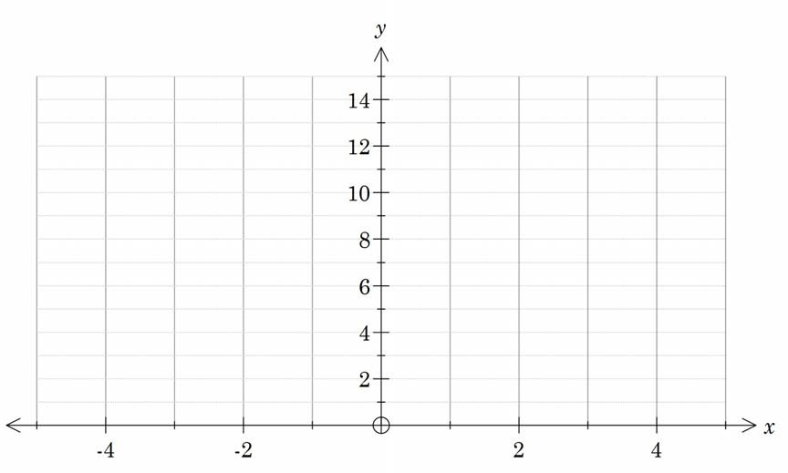
- Graph the function $f\left(x\right)=\left|3x-5\right|+|2x-1|$ below. Label key features.

- Express the function using a piecewise definition.

- Explain the link between the gradient and intersection points of the different sections of the graph and the original absolute value equation.

Exploring Mathematics – Perth Arena

The design of Perth Arena is based on Christopher Monckton’s Eternity puzzle. The Eternity puzzle comprises of 209 irregular shaped pieces that fit on a dodecagon shaped board. A selection of these puzzle pieces was used to design the Perth Arena. Each puzzle piece represents Western Australian icons; Perth’s Trojan horse, a cockatoo, a drill rig, a sailing boat, truck referencing to mining industry, Rottnest island, a swan and Western Australia.

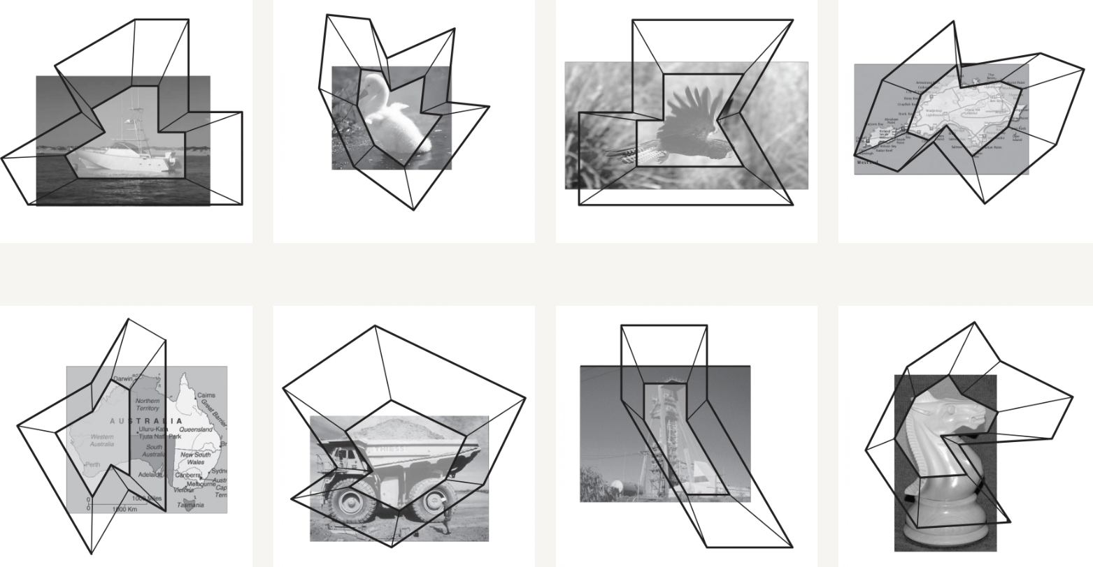

Your task is to determine a piecewise defined function and an absolute value function for one of the puzzle pieces given above. Due to the limitations of this course, we will determine function for only a part of the puzzle piece.
An example is shown below:
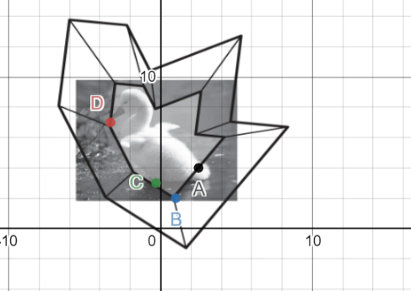

Desmos link : https://www.desmos.com/calculator/xcxzril6fz

- Determine a piecewise-defined function to describe the part of swan puzzle piece.

- Determine an equation of the form $f\left(x\right)=\left|ax+b\right|+\left|cx+d\right|+e$, to describe the part of swan puzzle piece.

- Now, your task is to choose another puzzle piece and find an absolute function for the part of that puzzle piece. Use your findings from question 3 to decide the part of the puzzle. Use desmos graphing calculator to investigate the graphs of $y=\left|ax+b\right|+\left|cx+d\right|+e.$
You can use classpad or desmos to complete this activity. Some parts of the puzzle pieces are suggested below.
Puzzle Piece |  | Desmos link
Trojan Horse  $$y=\left|ax+b\right|+\left|cx+d\right|+e$$ | 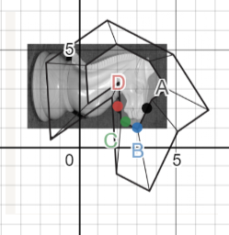 | https://www.desmos.com/calculator/n0tjstkfmw
Sailing Boat  $$y=\left|ax+b\right|-\left|cx+d\right|±e$$ | 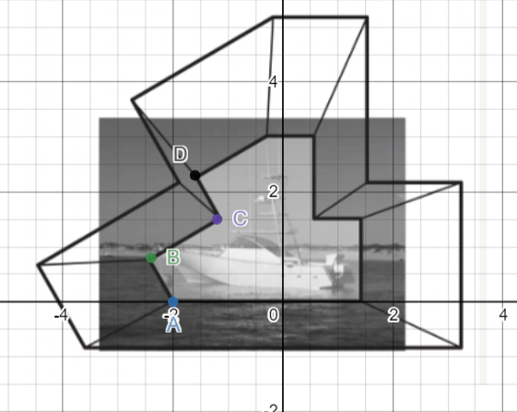 | https://www.desmos.com/calculator/t4boxllhtn

Solution
Absolute value functions
- Graph the function $f\left(x\right)=\left|3x-5\right|+|2x-1|$ below. Label key features.
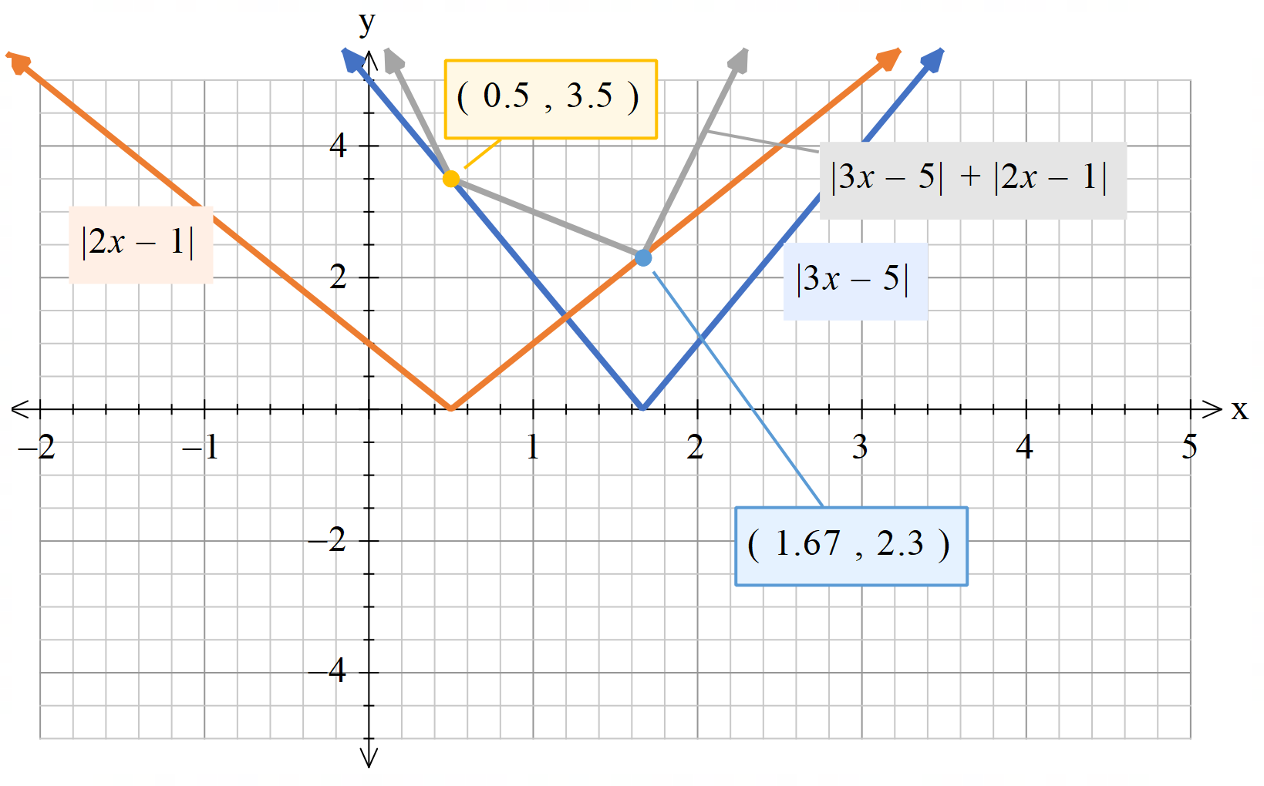

- Express the function using a piecewise definition.

Piecewise function =$\left\{\begin{aligned}-5x+6, x<0.5 \\ -x+4, 0.5≤x<1.67 \\ 5x-6, x≥ 1.67\end{aligned}\right.$

- Explain the link between the gradient and intersection points of the different sections of the graph and the original absolute value equation.

$$For x<0.5, the sum of-\left(2x-1\right) and-\left(3x-5\right) i.e-5x+6$$
$$For 0.5≤x<1.67, the sum of-\left(3x-5\right) and \left(2x-1\right) i.e. -x+4$$
$$For x≥ 1.67, the sum of \left(2x-1\right)and \left(3x-5\right) i.e. 5x-6$$

For puzzle piece - Swan
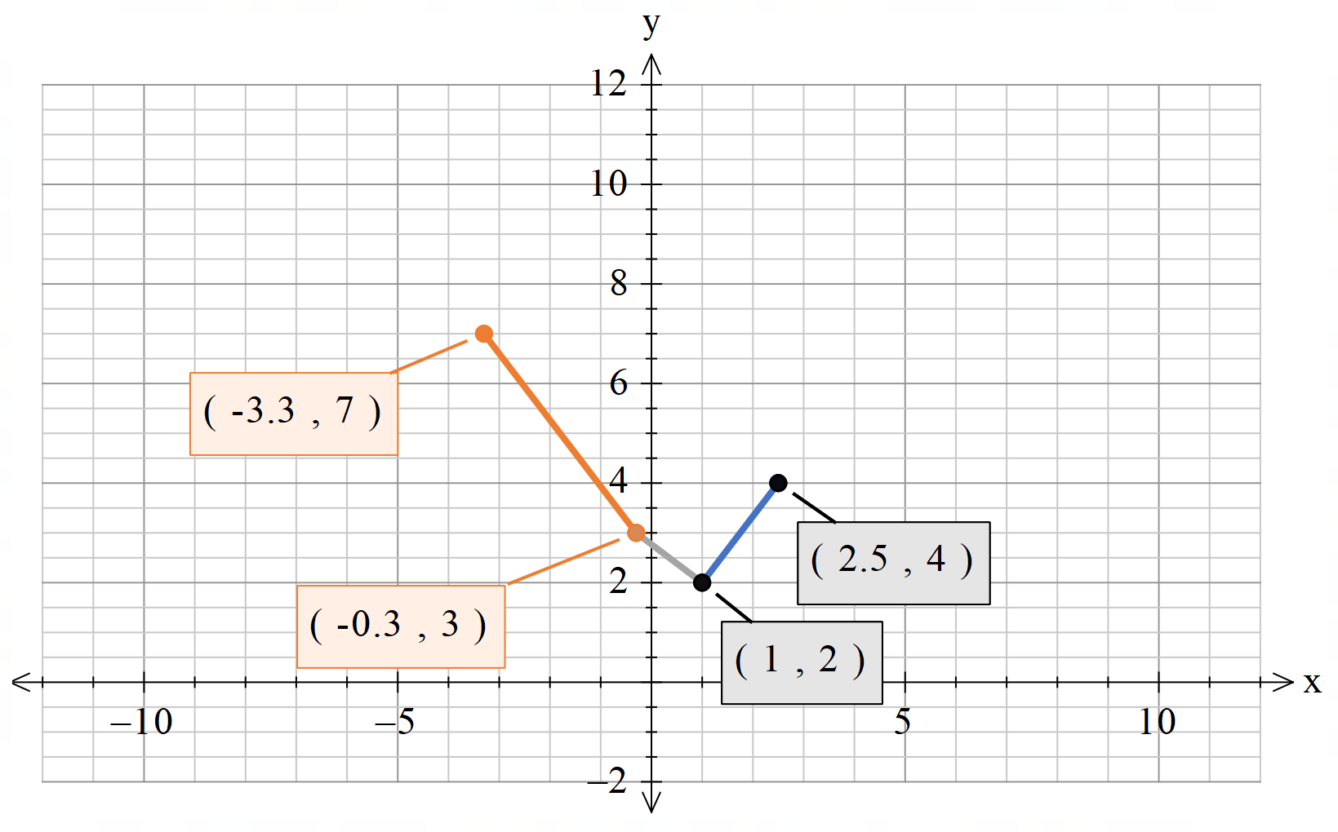

Orange line
$$gradient= \frac{7-3}{-3.3+0.3}= \frac{-4}{3} or-1.33$$
Equation of line => $y=\frac{-4}{3}x+\frac{13}{5}$

Grey line
$$gradient= \frac{2-3}{1+0.3}= \frac{-10}{13} or-0.77$$
Equation of line => $y=\frac{-10}{13}x+\frac{36}{13}$

Blue line
$$gradient= \frac{4-2}{2.5-1}= \frac{4}{3} or 1.33$$
Equation of line => $y=\frac{4}{3}x+\frac{2}{3}$

Piecewise function =$\left\{\begin{aligned}\frac{-4}{3}x+\frac{13}{5}, -1≤x<-0.3 \\ \frac{-10}{13}x+\frac{36}{13}, -0.3≤x<1 \\ \frac{4}{3}x+\frac{2}{3}, 1≤x≤2\end{aligned}\right.$

Gradients = $\left\{\begin{aligned}a+c=\frac{4}{3} \\ a-c=\frac{-10}{13}\end{aligned}\right.$

$$x-intercepts$$
$$\frac{-b}{a}= -0.3$$
$$\frac{-d}{c}=1$$
When x = 0, $\left|b\right|+\left|d\right|+e= \frac{36}{13}$

Solving equations
$$a= \frac{11}{39} ;b= \frac{11}{130};c= \frac{41}{39};d=\frac{-41}{39};e= \frac{49}{30}$$

On desmos -- https://www.desmos.com/calculator/qt4ldakjhc

References
- https://archello.com/project/perth-arena-a-giant-puzzle-of-3d-architecture
- https://armarchitecture.com.au/projects/rac-arena/
- https://www.desmos.com/

